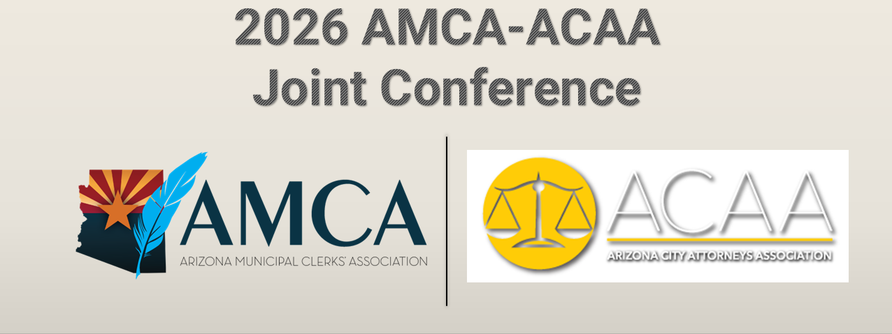

CONTINUING LEGAL EDUCATION
Certificate of Attendance

2026 AMCA-ACAA Joint Conference
Virtual
October 6 - 7, 2026

Open Meeting Law & Public Records Law: Real-World Issues, Risks & Solutions  (Tues., October 6, 2026, at 8:30-10:00 a.m., Presenters: Jon Paladini, Partner, Pierce Coleman PLLC; Dana DeLong, Town Clerk, Town of San Tan Valley) | 1.5 CLE Total____
AI at City Hall: Innovation, Responsibility & What Comes Next  (Tues., October 6, 2026, at 10:05-11:05 a.m., Presenters: Zach Klinefelter, Chief of Emerging Technology, Town of Gilbert; Ben Lane, City Clerk, City of Scottsdale; Luis Santaella, City Attorney, City of Scottsdale) | 1.0 CLE Total____
Better Together: Building Strong Clerk & Attorney Office Partnerships  (Tues., October 6, 2026, at 11:10 a.m-12:30 p.m., Presenters: David Udall, Deputy Town Attorney, Town of Marana, Jill McCleary, Town Clerk, Town of Marana, Chris Payne, Town Attorney, Town of Gilbert, Chaveli Herrera, Town Clerk, Town of Gilbert) | 1.25 CLE Total____
Election Law in Action: Candidates, Campaigns & the Issues in Between  (Wed., October 7, 2026, at 8:30 a.m. -10:00 a.m., Presenters: Christina Estes-Werther, Partner, Pierce Coleman PLLC; Kristi Passarelli, City Clerk, City of Surprise) | 1.5 CLE Total____

From the Gavel to the Minutes: Navigating Council Procedures & Parliamentary Issues  (Wed., October 7, 2026, at 10:05 a.m. – 11:05 a.m., Presenters: Jennifer Ekblad, City Clerk, City of Chandler; Kelly Schwab, Retired City Attorney, City of Chandler) | 1.0 CLE Total____
What’s New in Municipal Law? Legislative & Legal Updates for Arizona Communities  (Wed., October 7, 2026, at 11:10 a.m. - 12:30 p.m., Presenters: Rodney Short, Deputy City Attorney, City of Yuma; Denise Archibald, City Clerk, City of Phoenix) | 1.25 CLE Total____

In its entirety, this program may provide up to 7.5 CLE credit hours, including up to 0 Ethics CLE credit hours, based on a 60-minute hour. Introductory remarks, keynote addresses, business meetings, breaks, receptions, etc., are not to be included in the computation of credit. The State Bar of Arizona does not approve or accredit CLE activities for the Mandatory Continuing Legal Education requirement.

TO BE COMPLETED BY ATTORNEY: I certify that I attended the program, or a portion of the program, described above and I am entitled to claim _____ CLE credit hours, including 0 Ethics CLE credit hours.

Attorney (please print) Signature

