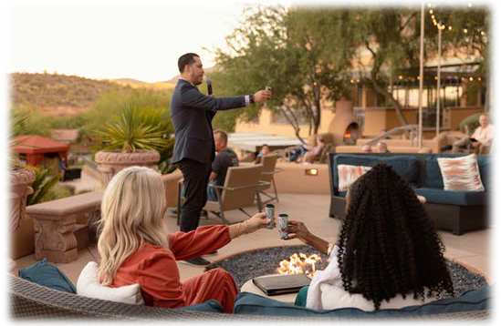
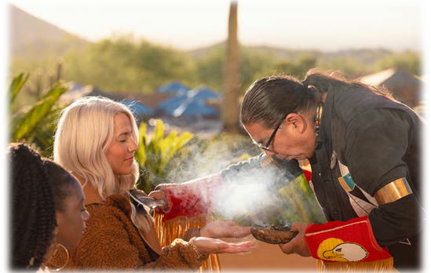
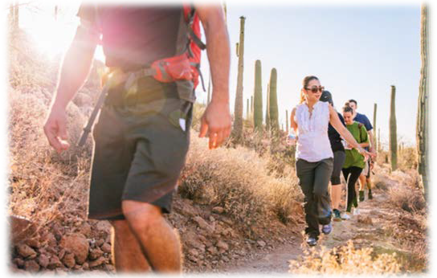
DAILY RITUALS

MITAKUYE OYASIN MORNING RITUAL – ALL MY RELATIONS
We invite you to join us each
morning at 7:00 AM on the Salud Terrace to participate in a traditional Native American ceremony and unique Sonoran Desert experience.
Begin each day by reflecting on the connection we all have with nature and each other, finding focus and creating lasting memories.

LEGEND OF ARRIBA ABAJO – NIGHTLY TEQUILA TOAST
We invite you to join us each
evening at 5:30 PM on the Salud Terrace to participate in our nightly Tequila Toast. Our tequila toast brings resort guests together on Salud Terrace at sunset to partake in the "Legend of Arriba Abajo” and celebrate with old friends and new.

AUTHENTIC TRAIL ADVENTURES-DAILY GUIDED HIKE
From the Resort's main lobby, facing west into the mountains, Tucson Mountain Park awaits you. Each morning a complimentary professional guide is here to help you experience this hike. You can also partner with your own professional guide to facilitate a custom outing (fees apply). Please check with our concierge for times and availability.

