HOTEL OUTLETS
General Hours of Operation are subject to change based on occupancy.

Experience Southwestern cowboy cuisine boasting flavors honed from rich, local cultures at Signature Grill, our popular Tucson restaurant with classic Native American and Mexican dishes prepared with locally grown, farm fresh produce and custom spice.

Breakfast: 6:30 AM – 11:00 AM
Lunch: 11:00 AM – 2:00 PM
Dinner: Sun-Wed 5:00 PM - 8:00PM

Dine below the stars near mesmerizing fire pits on Salud's outdoor terrace. Take in the captivating views of the downtown Tucson, while enjoying authentic Mexican cuisine, hand-crafted cocktails, and fine tequilas from an extensive list of selections.
Daily 3:00 PM - 10:00 PM

Farm-fresh herbs and produce from our organic garden, local growers, and farmer’s market ensure the most flavorful ingredients possible. This yields imaginative regionally inspired dishes with emphatic flavors.
Thurs-Sat: 5:00 PM - 9:00 PM Happy Hour: 5:00 PM - 6:30 PM

Lounge next to our shimmering outdoor pool with refreshing drinks and appetizing cuisine in a rejuvenating environment at Plunge Poolside Dining. Our casual restaurant and bar offers tasty dishes, a great kid’s menu and easy take – out options in Tucson.
Daily; 11:00 AM – 3:00 PM

Satisfy your cravings at JW Market, an on-the-go marketplace restaurant with locally inspired cuisine, specialty snacks and products from Tucson’s finest purveyors as well as regionally inspired flatbreads, delicious artisan sandwiches and salads to go.
Daily: 11:00 AM – 5:00 PM

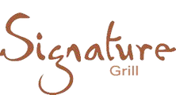
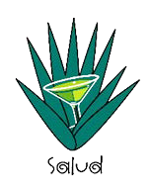
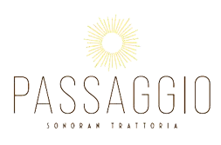



Jump start your morning with a steaming cup of coffee, specialty teas or other drinks at Starbucks®, our casual grab-and-go restaurant with pre-made snacks, sandwiches, and meals for busy days.
Open Daily 6:00 AM – 3:00 PM


Please scan the QR Code to view our dining menus.

