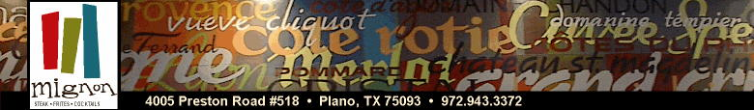

Reservation and Cancelation Policy

If you are interested in hosting your event at Mignon, please contact Nick Natour to reserve one of our private dining rooms. Please note that while we do not charge a room fee, we do require a signed contract and a credit card to hold your reservation. Your reservation is not confirmed until this policy is met as more than one group may have interest in the same date.

Additional servers are staffed to prepare for your group and quality, fresh food is prepared so that we may provide the best experience to our private dining guests. We work very hard to insure that your event will be flawless. Because of this, cancelations or “no-shows” will result in a cancelation fee on your credit card in the amount of your party minimum as determined, based on the size of your group. Of course, we understand that unforeseen circumstances may arise, and there is no penalty if you need to reschedule. Groups are permitted one change of date per event. Change of date must be within 45 days of original event.

Contact Information

If you wish to inquire further information about a private dining room please contact:

Lacy Bradford
Special Events
(469) 744-0701

Nick Natour
General Manager
(972) 943-3372
mignonplano@verizon.net

13/13
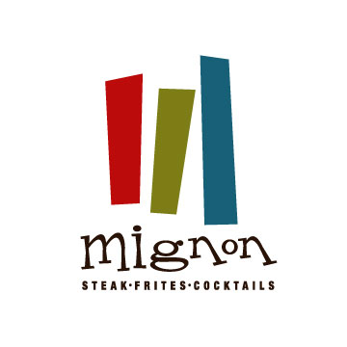
Hors d’oeuvre Selections
Please select 3 of the following: $12.00 per person per hour

Smoked Salmon Salad with Egg, Capers and Chive-Lemon Aioli on Potato Guafrette

Tomato-Basil Crostini with Olives and Fresh Buffalo Mozzarella

Wild Mushroom Bruschetta with Fontina and Veal Jus

Pepper Crusted Steak Carpaccio w/ Arugula, Parmesan, Grain Mustard and
Caper Aioli on Crostini

Spring Onion, Leek and Goat Cheese Tartlets

Mini Crab Cakes with Spicy Aioli

Chicken Wing Lollipops

Forest Mushroom Strudel with White Truffle Oil

12/13
3rd
Please select one of the following
Roasted Chilean Sea Bass
Potato-Chive Raviolis, Roasted Baby Artichokes & Black Truffle Jus
Lobster Tail 16 oz
White Truffle Risotto & Asparagus
Grilled Prime Filet “Mignon” 12oz.
White Cheddar Whipped Potatoes with Brandy Foie Gras Sauce
Seared Maine Diver Scallops
Roasted Jumbo Asparagus, Oven Cured Tomatoes & Peppered Goat Cheese
Mint Crusted Rack of Lamb 16 oz.
White Cheddar and Dino Kale Grits with Port Wine Balsamic Figs
Prime Grilled Ribeye 24 oz.
Lyonnaise Potatoes, Bacon and Chimichurri Sauce
Grilled Prime New York Strip 18 oz.
Roasted Fingerling Potatoes and Garlic Anchovy Butter
Kurobuta Pork Chop 16 oz.
Brussel Sprout Leaves, Bacon, Roasted Potatoes, with Sour Cherry Jus

4th
Please select one of the following
White Chocolate & Grand Marnier Bread Pudding
Butter Pecan Ice Cream
White Chocolate & Cinnamon Crème Brulée
(A Must with Cappuccino!)
Molten Chocolate Cake
Strawberry Ice Cream Granny
Tarte Tatin
Smith Apples & Vanilla Ice Cream
Banana, Chocolate & Hazelnut Crepes

Sides
(Additional 5.00 per person)
Macaroni & Cheese * Pomme Frites * Sautéed Mushrooms
Smoked Jalapeno Au Gratin Potatoes * French Green Beans
Creamed Spinach & Roasted Garlic
Creamed Corn & Bacon * Forest Mushroom & Truffle Risotto
Sautéed Brocolini * Grilled Asparagus

11/13
Four Course Premium Dinner Menu
85.00 per guest

1st
The following may be served family style if you choose
Jumbo Lump Crab Cake
Lobster Cream, Braised Fennel, Tomato Confit
Apple Smoked Bacon Wrapped Texas Quail
Savory Bread Pudding and Vanilla Infused Cherries
Steak Tartare
Raw Prime Tenderloin, Dijon Mustard, Capers, Lemon Juice & Shallots
Seared Hudson Valley Foie Gras
Onion Jam & Chocolate Port Wine Sauce
Jumbo Shrimp Cocktail
Classic Cocktail Sauce
Goat Cheese Gnocchi
Wild Mushroom & Basil Veal Jus

2nd
Please select one of the following
Warm Spinach Salad
Roasted Butternut Squash, Bacon, Black Currants, Crispy Onions, & Mustard Grain Vinaigrette
Grilled Pear Salad
Field Greens, Crispy Onions, Bleu Cheese, Honey-White Balsamic
Carpaccio of Beets Salads
Goat Cheese Croquettes, Arugula, Sherry Vinaigrette
Baby Iceberg Wedge
Oven Dried Tomato, Pancetta & Crouton with Bleu Cheese
Lobster Bisque
Brie & Mushroom Soup

Continued On Next Page

10/13
Four Course Dinner Menu
62.00 per guest

1st
The following may be served family style if you choose
Jumbo Lump Crab Cake
Lobster Cream, Braised Fennel, Tomato Confit
Apple Smoked Bacon Wrapped Texas Quail
Savory Bread Pudding and Vanilla Infused Cherries
Cigars of Pulled Beef Tenderloin
Chili Garlic & Mint Yogurt Sauces
Crispy Calamari
Sweet Tomato Chutney and Tomatillo Sauce
2nd
Please select one of the following
Petit Boston Bibb Salad
Granny Smith Apples, Candied Walnuts, Blue Cheese & Grain Mustard Vinaigrette
Hearts of Romaine Caesar Salad
Brioche Croutons & Shaved Parmesan
Lobster Bisque
3rd
Please select one of the following
Roasted Chilean Sea Bass
Potato-Chive Raviolis, Roasted Baby Artichokes & Black Truffle Jus
Pan Roasted Chicken
Fingerling Potatoes, Roasted Onions, Corn & Sweet Sherry Au Jus
Grilled Prime Filet “Mignon”
White Cheddar Whipped Potatoes with Brandy Foie Gras Sauce
Seared Maine Diver Scallops
Roasted Jumbo Asparagus, Oven Cured Tomatoes & Peppered Goat Cheese
Mint Crusted Rack of Lamb
White Cheddar and Dino Kale Grits with Port Wine Balsamic Figs
Prime Grilled Ribeye
Lyonnaise Potatoes, Bacon & Chimichurri Sauce
4th
Please select one of the following
White Chocolate & Grand Marnier Bread Pudding
Butter Pecan Ice Cream
White Chocolate & Cinnamon Crème Brulée
(A Must with Cappuccino!)
Molten Chocolate Cake
Strawberry Ice Cream
9/13
Three Course Dinner Menu
52.00 per guest

1st
Please select one of the following
Petit Boston Bibb Salad
Granny Smith Apples, Candied Walnuts, Blue Cheese & Grain Mustard Vinaigrette
Hearts of Romaine Caesar Salad
Brioche Croutons & Shaved Parmesan
Lobster Bisque

2nd
Please select one of the following
Roasted Chilean Sea Bass
Potato-Chive Raviolis, Roasted Baby Artichokes & Black Truffle Jus
Pan Roasted Chicken
Fingerling Potatoes, Roasted Onions, Corn & Sweet Sherry Au Jus
Seared Maine Diver Scallops
Roasted Jumbo Asparagus, Oven Cured Tomatoes & Peppered Goat Cheese
Grilled Prime Filet “Mignon”
White Cheddar Whipped Potatoes with Brandy Foie Gras Sauce
Mint Crusted Rack of Lamb
White Cheddar and Dino Kale Grits with Port Wine Balsamic Figs
Grilled Ribeye
Lyonnaise Potatoes, Bacon and Chimichurri Sauce

3rd
Please select one of the following
White Chocolate & Cinnamon Crème Brulée
(A Must with Cappuccino!)
White Chocolate & Grand Marnier Bread Pudding
Butter Pecan Ice Cream
Molten Chocolate Cake
Strawberry Ice Cream

8/13
Four Course Lunch Menu
45.00 per guest

1st
Served Family Style
Jumbo Lump Crab Cake
Lobster Cream, Braised Fennel & Tomato Confit
Applewood Smoked Bacon Wrapped Texas Quail
Savory Bread Pudding and Vanilla Infused Cherries
Cigars of Pulled Beef Tenderloin
Chili Garlic & Yogurt Mint Sauces
Crispy Calamari
Sweet Tomato Chutney and Tomatillo Sauce

2nd
Please select one of the following
Petit Boston Bibb Salad
Granny Smith Apples, Candied Walnuts, Blue Cheese & Grain Mustard Vinaigrette
Hearts of Romaine Caesar Salad
Brioche Croutons & Shaved Parmesan
Lobster Bisque

3rd
Please select one of the following
Pan Roasted Atlantic Salmon
Creamed White Corn, Spinach, Bacon & Balsamic Butter
Pan Roasted Chicken
Fingerling Potatoes, Roasted Onions, Corn & Sweet Sherry Au Jus
Prime Steak Frites 10 oz.
Roasted Garlic and Demi Glace
Cochon
Braised Pork Shank, Sweet Potato Gnocchi, Swiss Chard, Honey Glazed Bacon Wrapped Figs,
Cochon Demi & Cilantro Infused Olive Oil

4th
Please select one of the following
White Chocolate & Cinnamon Crème Brulée
(A Must with Cappuccino!)
White Chocolate & Grand Marnier Bread Pudding
Butter Pecan Ice Cream
Molten Chocolate Cake
Strawberry Ice Cream
7/13
Three Course Lunch Menu
39.00 per guest

1st
Served Family Style
Jumbo Lump Crab Cake
Lobster Cream, Braised Fennel & Tomato Confit
Applewood Smoked Bacon Wrapped Texas Quail
Savory Bread Pudding and Vanilla Infused Cherries
Cigars of Pulled Beef Tenderloin
Chili Garlic & Yogurt Mint Sauces
Crispy Calamari
Sweet Tomato Chutney and Tomatillo Sauce

2nd
Please select one of the following
Pan Roasted Atlantic Salmon
Creamed White Corn, Spinach, Bacon & Balsamic Butter
Pan Roasted Chicken
Fingerling Potatoes, Roasted Onions, Corn & Sweet Sherry Au Jus
Prime Steak Frites 10 oz.
Roasted Garlic and Demi Glace
Cochon
Braised Pork Shank, Sweet Potato Gnocchi, Swiss Chard, Honey Glazed Bacon Wrapped Figs,
Cochon Demi & Cilantro Infused Olive Oil

3rd
Please select one of the following
White Chocolate & Cinnamon Crème Brulée
(A Must with Cappuccino!)
White Chocolate & Grand Marnier Bread Pudding
Butter Pecan Ice Cream
Molten Chocolate Cake
Strawberry Ice Cream

6/13
Three Course Lunch Menu
33.00 per guest
(Lunch Only)

1st
Please select one of the following
Petit Boston Bibb Salad
Granny Smith Apples, Candied Walnuts, Blue Cheese & Grain Mustard Vinaigrette
Hearts of Romaine Caesar Salad
Brioche Croutons & Shaved Parmesan
Lobster Bisque

2nd
Please select one of the following
Pan Roasted Atlantic Salmon
Creamed White Corn, Spinach, Bacon & Balsamic Butter
Pan Roasted Chicken
Fingerling Potatoes, Roasted Onions, Corn & Sweet Sherry Au Jus
Prime Steak Frites 10 oz.
Roasted Garlic and Demi Glace
Cochon
Braised Pork Shank, Sweet Potato Gnocchi, Swiss Chard, Honey Glazed Bacon Wrapped Figs,
Cochon Demi & Cilantro Infused Olive Oil

3rd
Please select one of the following
White Chocolate & Cinnamon Crème Brulée
(A Must with Cappuccino!)
White Chocolate & Grand Marnier Bread Pudding
Butter Pecan Ice Cream
Molten Chocolate Cake
Strawberry Ice Cream

For $27.00 Guests may select either an appetizer OR dessert

5/13
Three Course Lunch Menu
27.00 per guest
Guests may select an appetizer OR a dessert
(Lunch Only)

1st
Please select one of the following
Hearts of Romaine Caesar Salad
Brioche Croutons & Shaved Parmesan
Tomato Basil Soup
Lobster Bisque

2nd
Please select one of the following
Prime Grilled Bacon Burger
White Cheddar & Pomme Frites
Sesame Seared Ahi Tuna Salad
Roasted Fingerling Potatoes, Romaine, Pickled Mango & Peanut Chili Garlic Sauce
Grilled Chicken Salad
Arugula, Applewood Smoked Bacon, Goat Cheese, Apricots, Toasted Almonds & White Balsamic Vinaigrette

3rd
Please select one of the following
White Chocolate & Cinnamon Crème Brulée
(A Must with Cappuccino!)
White Chocolate & Grand Marnier Bread Pudding
Butter Pecan Ice Cream
Molten Chocolate Cake
Strawberry Ice Cream

4/13

Menus
In order to provide the best possible dining experience, we ask groups of 12 or more to select a menu in advance. All of our meats, seafood and produce are ordered specially for your party to ensure freshness and quality. Additionally, preselected menus allow us to streamline service. For your convenience, we have included our set menus in this dining packet. These menus have several options available for each course. The dishes are a sampling of our most popular items, as well as our personal favorites.

There a few dining options available to you if you select a menu with an appetizer course. Some groups prefer to serve the appetizer course “family style” on large platters allowing everyone to sample each appetizer. Other groups prefer for each guest to select their own appetizers. The choice is completely up to you. An additional course of passed hors d’ouevres or heavy appetizers may be added to any menu.

Please be advised some menu items change seasonally. Please be aware that menu items and prices may be subject to change.

Custom Menus
We would also be happy to assist you in creating a custom menu for you for your event. If your favorite appetizer, salad, entrée or dessert is not included on one of the set menu options we would be happy to add it or build an entirely new menu for your unique party. Keep in mind that Kosher, vegetarian, and gluten free options are available. Please note that substitutions and additional selections may affect menu prices.

Beverages
Coffee, iced and hot teas, sodas, and beverages from our full bar are charged based on consumption. Some groups prefer to preselect red and white wines for their event. This can also be an effective way to control costs. We are happy to help you plan your beverage selections.

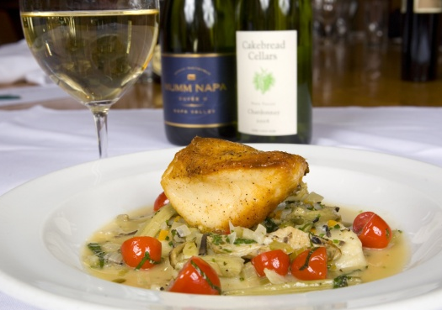

3/13

The Perfect Place for Your Next Soiree

Thank you for your interest in Mignon. We are excited you have chosen to host your special event with us! The enclosed packet has been designed to assist you in planning your event and ensure your event will be a great success.

With private dining spaces available for groups of 12 to 200 guests, Mignon is the perfect location for business luncheons, rehearsal dinners, showers, receptions, birthdays, cocktail parties, and corporate functions.

We are passionate about good food, wine and above all excellent service. Our exceptionally trained staff will provide you with a memorable dining experience, exceeding the expectations of your family and friends.

Please contact us to make party arrangements. We are happy to assist you and look forward to making your event an enjoyable one.

Cheers,

Lacy Bradford
Special Events

Nick Natour
General Manager

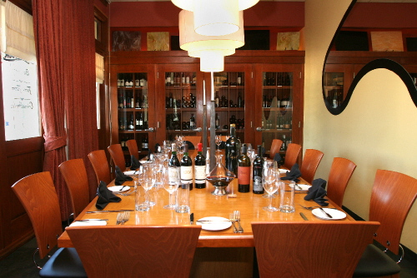
2/13
Mignon
Steaks * Seafood * Cocktails

4005 Preston Road Suite 518
Plano, TX 75093
(972) 943-3372
MignonPlano@verizon.net

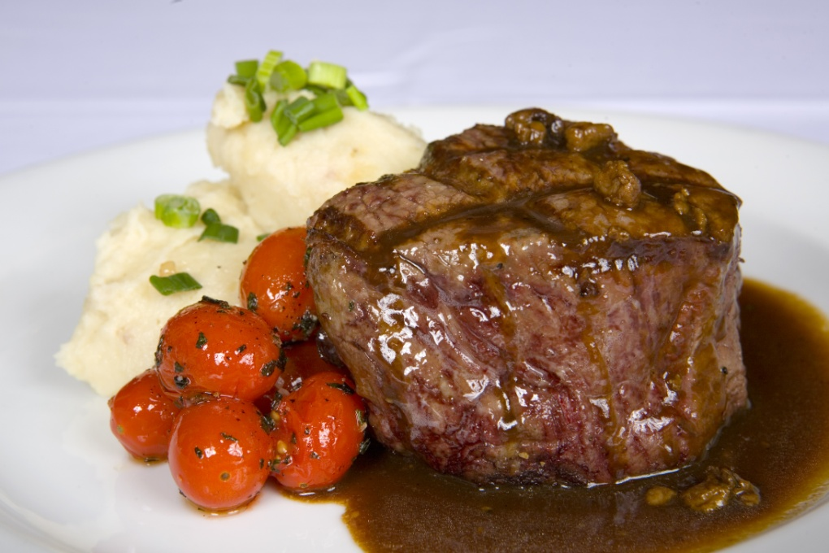

-The Dallas Morning News-

1/13
Pricing and menu items are subject to change without notice
Consuming raw or undercooked meats, poultry, seafood, or shellfish may increase your risk of foodborne illness

