The Georgian Terrace Hotel GENERAL FACTS

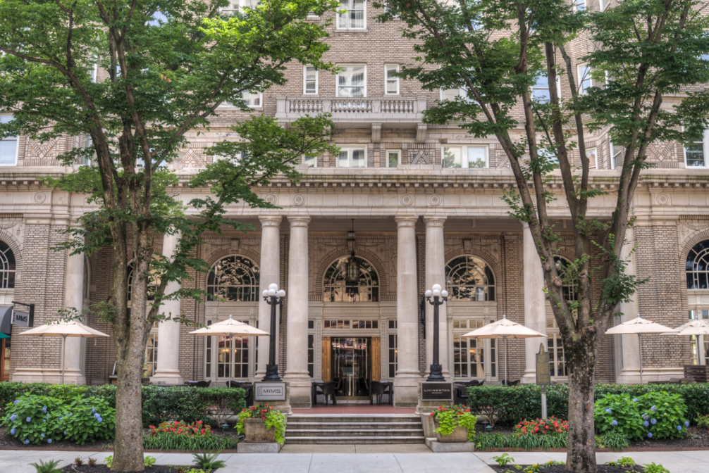
- Address/Phone/Internet Information:
659 Peachtree Street, N.E.  Atlanta, Georgia 30308  Phone: (404) 897-1991 | Sales Phone: (404) 898-8333  Toll-free reservations: (800) 651-2316  Web site: www.thegeorgianterrace.com
- Hotel Info./Features/Amenities:
Number of Rooms: 320 Guest Rooms & Suites + 6 Penthouse Suites
Suite Amenities: All rooms have coffee makers, iron/board, hair dryers
Some Suites have Full kitchens and washer/dryers
Restaurants: Livingston, Buffalo Bayou Cafe, Edgar’s Proof & Provision
Cocktail Lounges: Livingston Bar/Lounge, Proof & Provision
Check In/Out: Check In: 4:00 PM; Check out: 11:00 AM
Television: Standard cable service, In-room movies
Internet Connectivity: FREE WIFI throughout the hotel
Laundry Service: Valet service available, some in-room washer/dryers
Pets: Pets are allowed (restrictions apply)
Parking: Covered garage located adjacent to hotel.
Parking Fee: $45.00 Self-Parking Nightly |$55.00 Valet Parking Nightly
Rooms Taxes: + 18.79% Room tax (8.9% sales tax, 8% occupancy tax, 1.89% historical hotel fee)
And $5.00 Georgia state fee
Food/Bev/AV/Labor Taxes & Service Charge: 25% taxable service charge + 8.9% sales tax

Atlanta Conference Center:
16,000 square feet of meeting space is available in the Atlanta Conference Center, located on the ground floor of the hotel. The state-of-the art meeting facility features provides six meeting rooms, executive board room and three ballrooms. Pre-function areas are spacious and have floor-to-ceiling Palladian windows. The largest capacity for receptions is 350, while 200 can be accommodated for banquet style seating.

Grand Ballroom
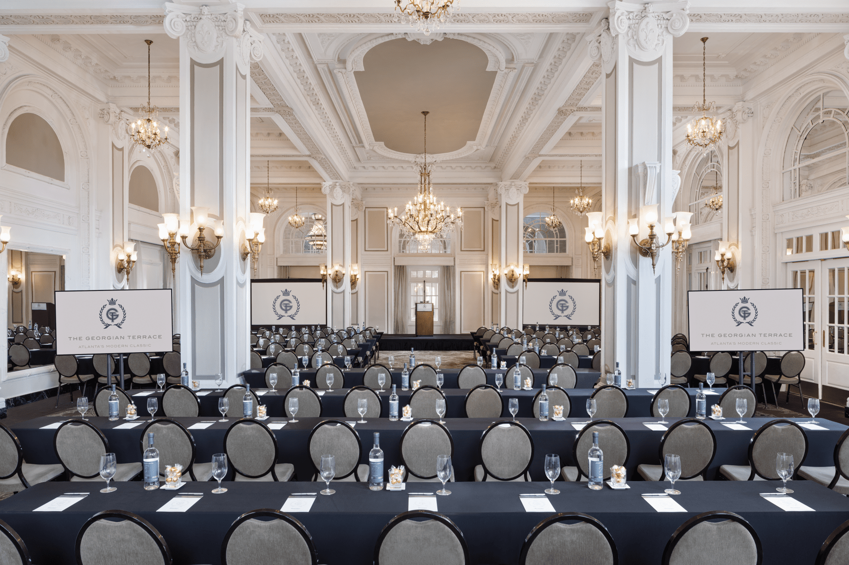

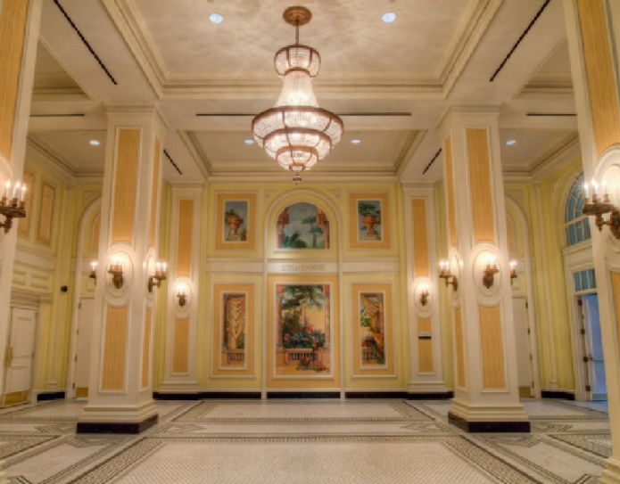
Piedmont Ballroom & Piedmont Ballroom Foyer (Lobby Level – Natural Light)
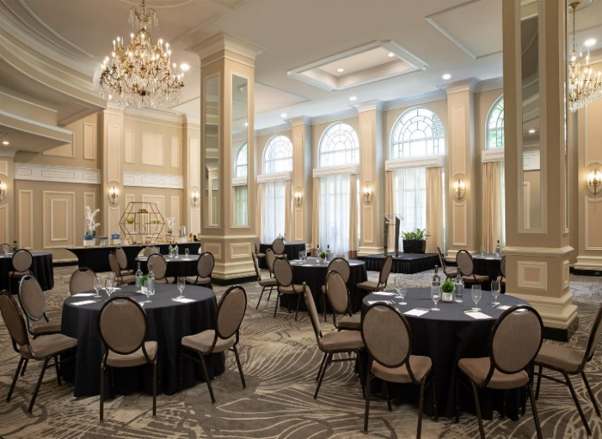
Mitchell Ballroom (Lobby Level – Natural Light)

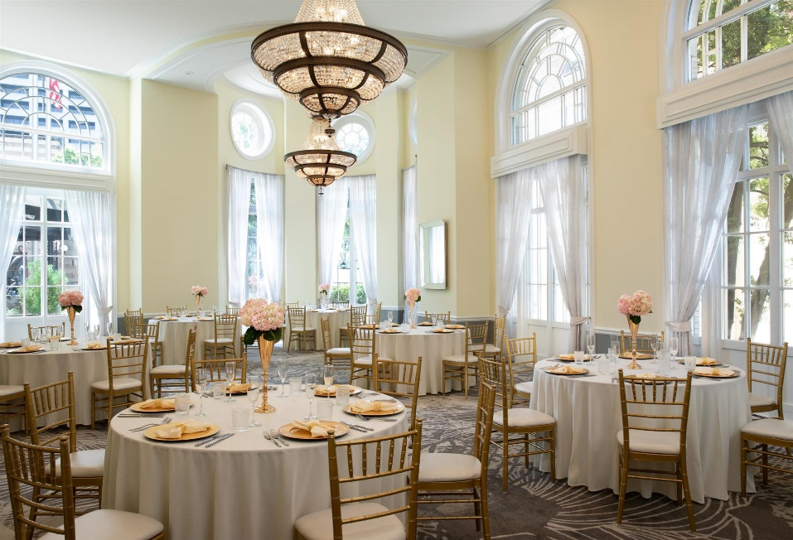

Hotel Restaurants/Lounges/Room Service:

The Livingston Restaurant & Bar
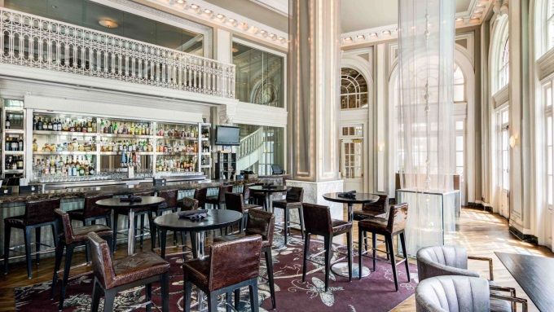
Restaurant in the original historic lobby, serving creative American Cuisine featuring outdoor terrace dining. 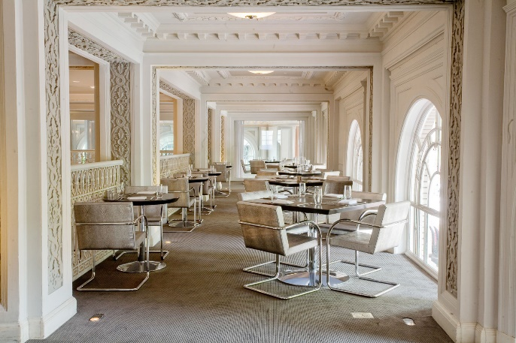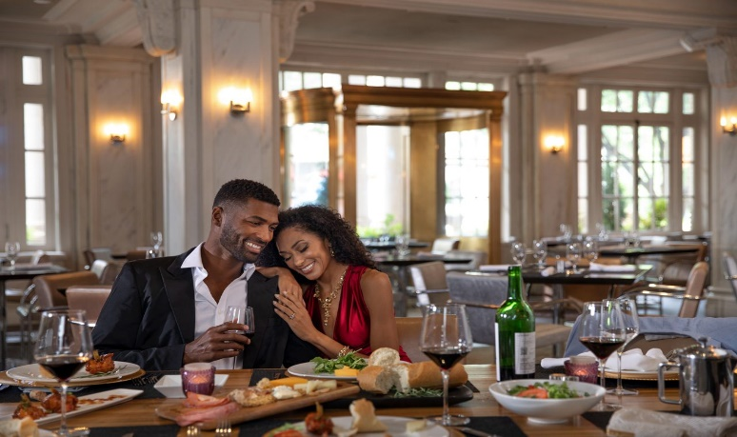
Livingston Mezzanine Livingston Restaurant

Edgar’s Proof & Provision
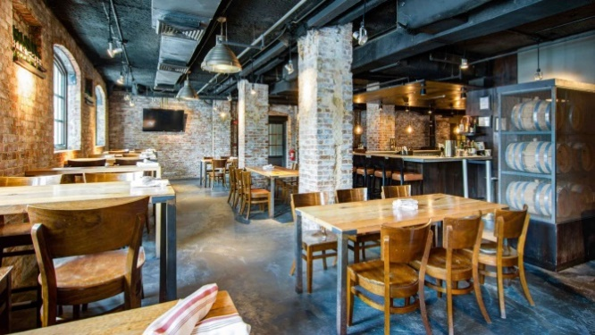
Opened in 2013, our version of a classic speak easy, features classic
and craft cocktails with an eclectic smaller bite menu. After 5:00 pm Tuesday to Saturday.

- Hotel History/Architecture:

To be great, a city must have a great hotel, a grand hotel. When Atlanta was coming into its own in the early 20th century that hotel was The Georgian Terrace Hotel. With its floor-to-ceiling windows, crystal chandeliers and white marble columns, The Georgian Terrace had an elegance Atlanta hadn’t known before. When the hotel opened its doors in glamorous Midtown nearly a century ago, it opened them to some very notable guests, including President Calvin Coolidge, F. Scott Fitzgerald, and Tallulah Bankhead. In 1939, The Georgian Terrace hosted the premiere gala of Gone with The Wind. Every decade brought more notoriety to the hotel. In the 1970s, concert promoter Alex Cooley turned our Grand Ballroom into the famed Electric Ballroom, hosting concerts by musicians such as Billy Joel, Bruce Springsteen, Fleetwood Mac, and Patti Smith. As Atlanta modernized its skyline many of its older buildings disappeared, but not The Georgian Terrace Hotel. As did the nearby Fox Theatre, this beautiful historic hotel had dedicated fans, and in 1986, it was added to the National Register of Historic Places.
Construction Date: Historic nine-story building: 1911; New 20-story tower: 1991
Original Construction Cost: $500,000, October 1911
Architecture: French Renaissance
Architect: W.L. Stoddart, New York City (1869-1940)
Historic Designation: Listed on the National Register of Historic Places
Affiliation: Member of Historic Hotels of America
Notable Historic Event: Premiere reception for Gone With The Wind held in Grand Ballroom, 1939.

- Sports/Recreation | Hotel Facilities:
The fitness center, wellness space, & rooftop patio are accessed on the 19th floor. The Fitness Center is equipped with free weights, Nautilus equipment, aerobics mats and cardio-fitness theatre. Restroom facilities with lockers and showers are also located in the fitness center. Massage therapy is available by appointment. The rooftop patio is 2000sf and features breathtaking unobstructive views of downtown, midtown, and Stone Mountain.
Recreational Activities Nearby:
Piedmont Park, located 6 blocks away has facilities for tennis, bicycle rentals, skate rentals, swimming, jogging, softball, and soccer. Bobby Jones Golf Course, 5 miles.
Professional |Collegiate Sporting Venues Nearby:
Mercedes Benz Arena Atlanta Falcons, Atlanta United, concerts 1 mile
State Farm Arena Atlanta Hawks, concerts, etc. 1 mile
Bobby Dodd Stadium Georgia Tech Yellow Jackets Stadium ½ mile
McCamish Pavilion Georgia Tech Yellow Jackets Arena ½ mile
GWCC Georgia World Congress Center 1.3 miles
Location | Getting Here:
Located in the heart of Midtown Atlanta, The Georgian Terrace Hotel can be found at the intersection of Peachtree Street and Ponce de Leon Avenue. Known throughout the southeast, as Atlanta’s oldest, historic, and iconic hotel, Hartsfield-Jackson Atlanta International Airport is only 10 miles to the south, and one mile north of the downtown central business district. Both the world’s busiest airport and downtown (convention/sports/business district) can be accessed via MARTA (www.itsmarta.com) and The historic Fabulous Fox Theatre is directly across Peachtree Street. Driving in for your visit, there is easy access to and from Interstate 75/85/20/285.

Nearby Attractions:
The Fox Theatre, Georgia Aquarium, World of Coca-Cola Museum, Center for Civil & Human Rights (Museum), Georgia Aquarium, College Football Hall of Fame, Ponce City Market (Rooftop venue, food hall, boutique shopping), Piedmont Park, Atlanta Botanical Garden, Atlanta History Center, Zoo Atlanta,
The Carter Presidential Center, Woodruff Arts Center, High Museum of Art, Margaret Mitchell House, Fernbank Museum of Natural History, Georgia Tech, Rhodes Hall, Center for Puppetry Arts, Jewish Heritage Museum, Atlantic Station (Outdoor Retail Mall, Dining and Attractions, see below), and so much more within a 20 minute drive!
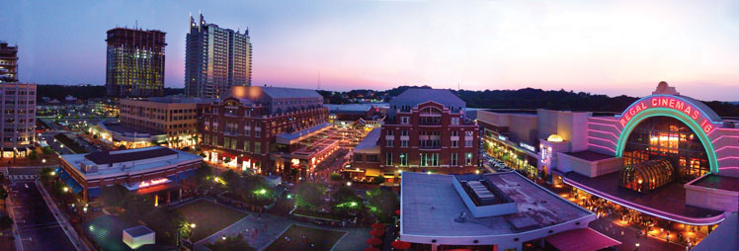

Map:
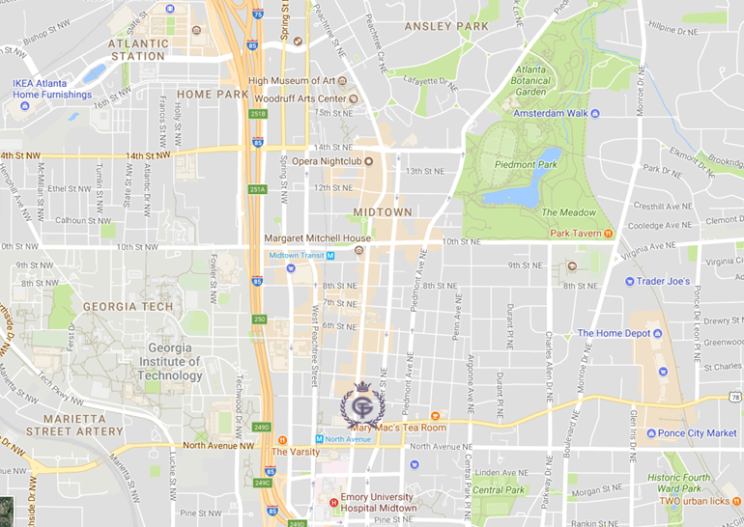

Area Services:
Closest Hospital: Emory Hospital, 3 blocks
Closest Grocery Store: Publix, 8 blocks
Closest Pharmacy: CVS Pharmacy, 5 blocks Walgreens Pharmacy, ½ mile
Closest ATM: Wells Fargo 1 block; Bank of America, 1 block.
Closest Movie Theatres: Midtown Promenade 8. 1 miles
Major Airport: Hartsfield-Jackson Atlanta International (ATL), 10 miles south
Convention Center: Georgia World Congress Center, 1 mile
Airport Transportation: $18.50 shuttle; $35.00 taxi, $2.75 MARTA (Rapid transit)
Rapid Transit: MARTA (www.itsmarta.com); North Avenue MARTA station located 2 blocks
Executive Airport: Peachtree/DeKalb Airport, 5 miles north

